SAP SuccessFactors Q4 2017 Review

By Stephen Burr, UK HCM Cloud Practice Manager, ROC

As we’ve seen in the previous posts (http://zalaris.co.uk/insights/blog/tag/successfactors) from my colleagues, this Q4 release contains a wide array of new features and improved functionality. Although the release contains a large number of EC, Platform and Recruiting changes, there is change in all areas. In this post I’m going to pick up on some of the recurring themes and what this might mean for the future of SAP SuccessFactors.

General Data Protection Regulation (GDPR)
I am sure by now that this is a term that needs little explanation (if it does, read here https://ico.org.uk/for-organisations/guide-to-the-general-data-protection-regulation-gdpr/ )! With the May 2018 introduction of this directive now under six months away, there are multiple changes discussed in the module blogs for this Q4 release.

Changes can be found in the Platform, Employee Central and almost all the Talent modules (Calibration, Onboarding, Learning, Performance & Goals, Recruiting, Succession & Development).

Many further changes are proposed in Q1 2018 (1802) with features addressing Change Logging, Read Access Logging, Data Subject Info, Data Purge, Data Blocking and Consent. This is a key and relevant topic as we, both as individuals and as employees, become more aware of the data we access, store and share. I expect the area of data privacy to be a hot topic beyond May 2018.

Business Beyond Bias
SAP’s commitment to “Business Beyond Bias” (https://youtu.be/-9T7cWSWEhE ) is using the machine learning, mentioned in last quarter’s summary (https://www.roc-group.com/news-and-events/blog/exploring-the-q3-2017-successfactors-update-b1708-part-10/), to help organisations detect and prevent unconscious bias.

In this Q4 release, we see two new areas related to bias. In Recruiting, there is an early adopter feature called “Job Analyzer” which analyzes the content of descriptions (English language only currently) in job requisitions to give insight into skills & salary information (US only currently), as well as gender bias.

In Calibration, the system can now issue alerts if certain scenarios occur (lack of promotion, leave of absence impacting rating and dramatics performance rating reduction). Alerting calibration session attendees to these scenarios, helps address bias, which is often unconscious and unintentional.

User Experience
As always, there are usability experiences across the suite both in look and feel (on the web and the mobile application), but also in how the system operates (with respect to browser time outs) and communicates (with much improved notification template capability). With Fiori updates becoming “Universal” in Q3 2018, and therefore requiring adoption by all customers, this is a good time to be considering how to ensure that Fiori’s full capability is being utilised, including the latest Home Page and People Profile.

In addition to this, a significant feature released this quarter is the embedding of external educational content (from Thrive Global www.thriveglobal.com/) into Employee Central … for free! This marks an expansion of SuccessFactors offering from a transactional HR into a more holistic HR system.

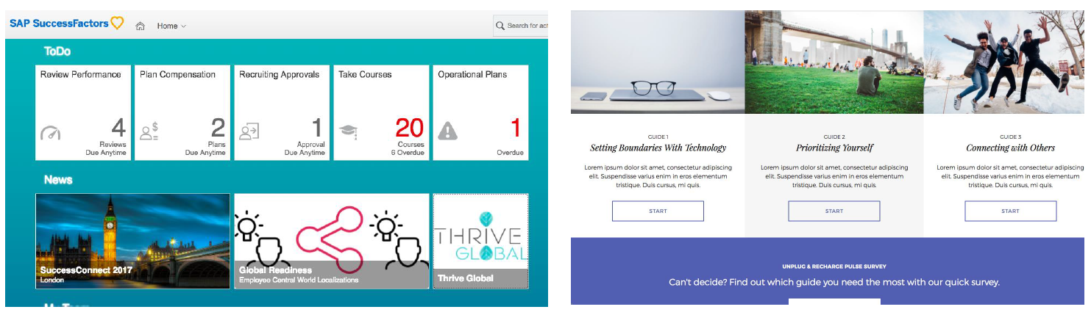

Integration
Another recurring theme is the improved interoperability of SAP products across SAP ERP, S/4HANA, SuccessFactors, Concur, SAP Analytics Cloud, Fieldglass, etc.
In this quarter there are numerous enhancements and notable fixes as well as the significant announcement of “People Central Hub”. This seems very early days but it is relevant to customers who don’t use Employee Central but want to simplify their often-complicated point-to-point integration landscape with a central “hub”. It will allow the consolidation of HR master data from various sources to immediately

visualise who works where in the organisation as well as allow all users to easily look up colleague’s contact details (online or via the mobile application).

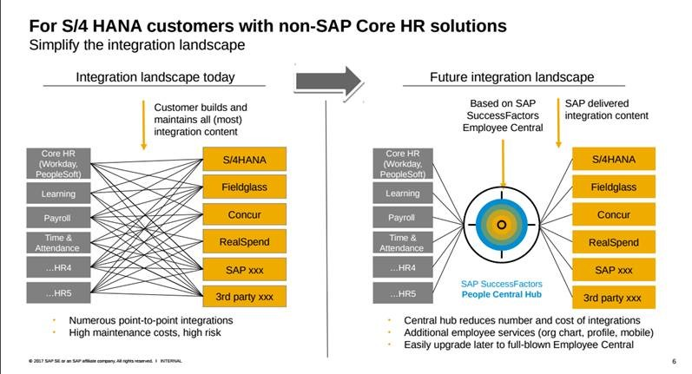

This is an interesting innovation and despite the lack of detail, it was significant enough for Amy Wilson, Head of Product at SAP SuccessFactors to mention in her Q4 Highlights (https://youtu.be/alxy-YAD5Ws) review. The SAP Help pages (https://help.sap.com/viewer/p/SAP_SUCCESSFACTORS_PEOPLE_CENTRAL_HUB) will be worth keeping an eye on to see how this is further communicated.

Conclusion
I hope you’ve enjoyed our series of posts on the Q4 2017 release of SAP SuccessFactors. If you haven’t read the other posts (http://zalaris.co.uk/insights/blog/tag/successfactors) yet I’d encourage you to go back and read them.

I’d like to take the opportunity to thank my colleagues once again for their hard work in bringing you their insights and I hope the larger SAP SuccessFactors community has found them useful too.

If you are interested in SAP SuccessFactors and our expertise in this area please reach out to us via our contact page (http://zalaris.co.uk/contact/) and we look forward to speaking to you soon.

